HackerRank Program 3
Link :- https://www.hackerrank.com/challenges/grading/problem

Successful Submission
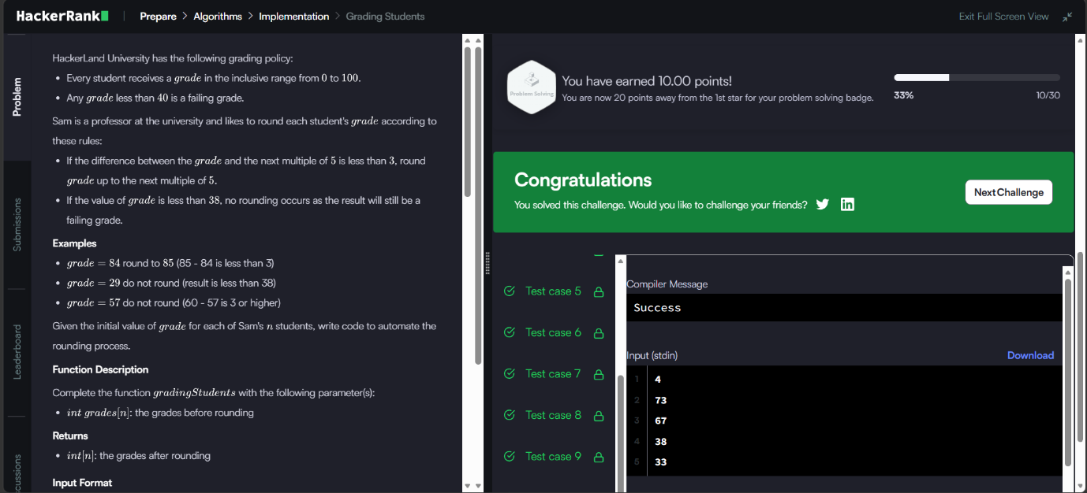
Source Code


